Doxygen Commenting Guidelines
To maintain consistency, readability, and clarity in the documentation generated using Doxygen, please follow these guidelines when adding comments to the codebase.
1. Use Proper Doxygen Tags
- Always use Doxygen's standard tags for documentation. The most commonly used tags are:
  - @brief: A short description of a function or class.
  - @param: Describes a function parameter.
  - @return: Describes the return value of a function.
  - @note: Additional important information.
  - @warning: Highlights cautionary information.
  - @todo: For marking incomplete sections or future improvements.
Example:
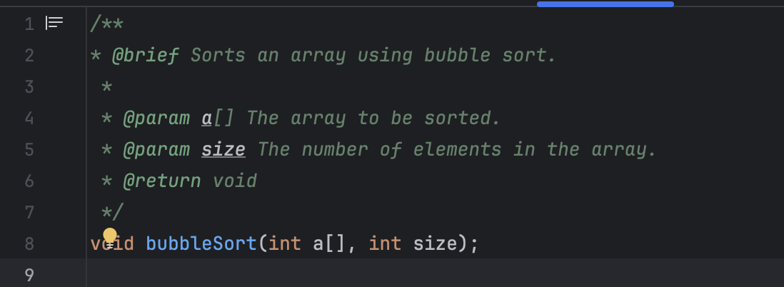

2. Write Meaningful Descriptions
- @brief should provide a concise overview.
- Follow up with additional details after @brief if necessary.
- Provide explanations for complex logic or algorithms within function documentation.
- Avoid redundant or overly verbose descriptions. Keep it simple but informative.
Example: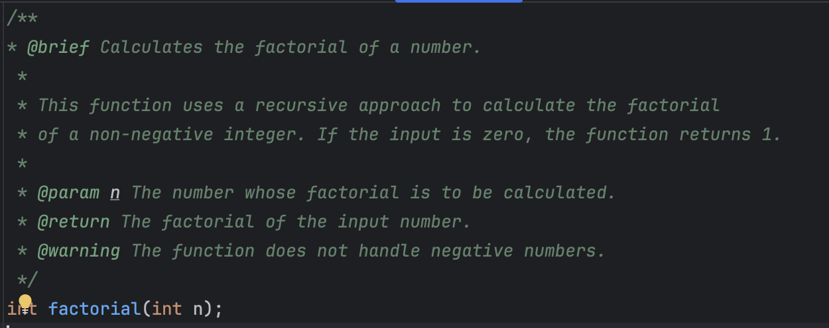

3. Document All Public Functions and Classes
- Every public function, class, method, and member variable must have a Doxygen comment. Include the purpose of the function, any parameters, and the expected return value.
- For class-level documentation, explain the class's overall purpose and important methods or members.
Example:
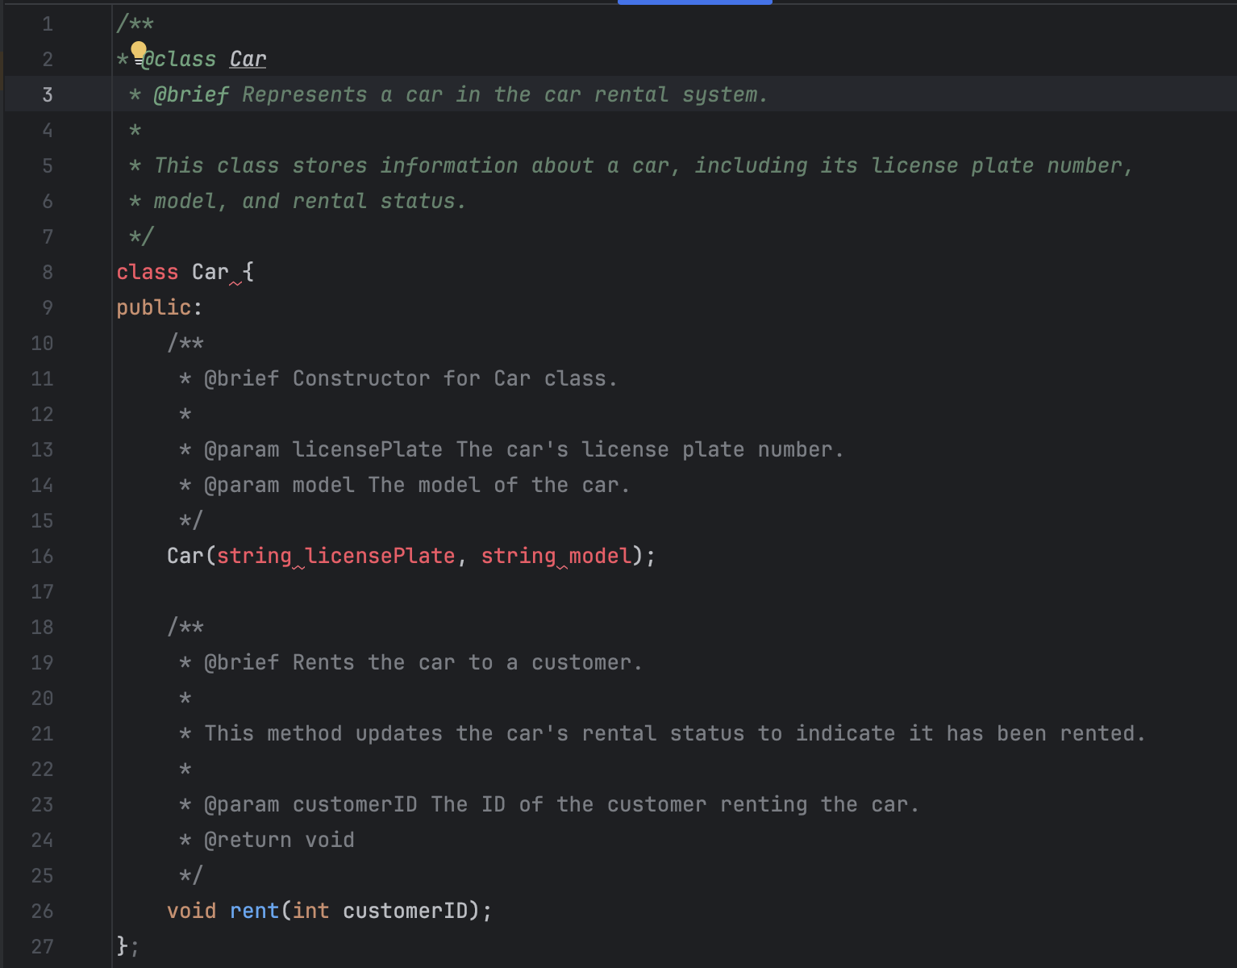

4. Document Parameters and Return Values
- Always use @param to describe all input parameters, specifying what they represent and any important constraints (e.g., "must be non-negative").
- Use @return to describe the function’s return value, even if it’s void or a simple type.
Example:
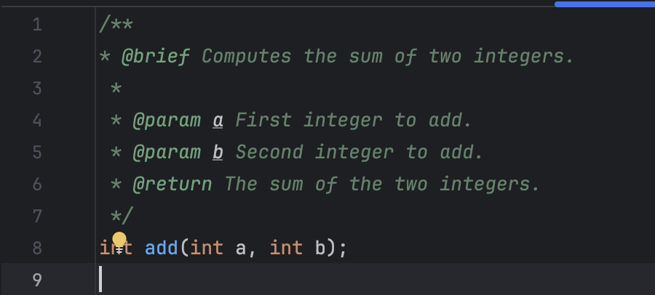

5. Handle Edge Cases and Warnings
- Use @warning or @note to indicate edge cases, potential pitfalls, or assumptions made by the function.
- Highlight performance issues or important conditions (e.g., if a function is not thread-safe).
Example:
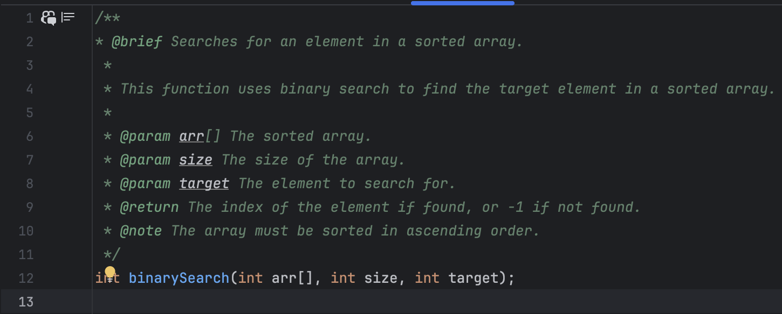

6. Keep Comments Up-to-Date
- Always update comments when the code is modified. Outdated or incorrect comments can cause confusion and mislead users.
- Ensure that the comments accurately reflect the functionality and behavior of the code.
7. Use Consistent Style
- Use consistent formatting, indentation, and punctuation in Doxygen comments across the codebase.
- Write comments in full sentences with proper grammar and punctuation for readability.
Example:
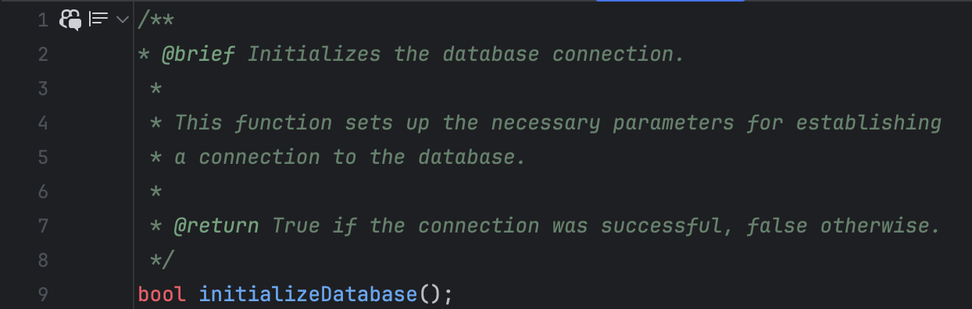

8. Private/Internal Code
- If internal or private methods need to be documented for development purposes, mark them clearly as internal using @internal or @private so that they are not included in public-facing documentation.
Example:
