Doxygen Commenters' Thread
- Commenting Guidelines Summary
@brief: A brief summary of the function or class.
@param: Details of function parameters.
@return: Explanation of what the function returns.
@warning: Highlights any important warnings.
@note: Provides additional information or notes on usage.
@todo: Indicates future work or improvements needed.

- Function Documentation
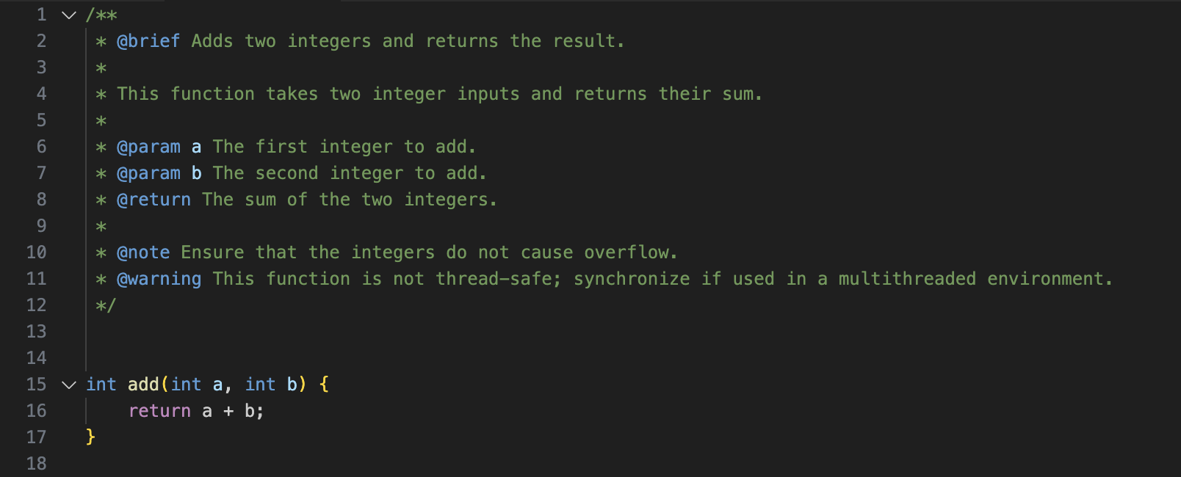
Explanation:
@brief: to provide a concise summary,
@param: tags for each parameter
@return: to describe the function's output.
@note: for additional information
@warning: to highlight a potential issue

- Class Documentation
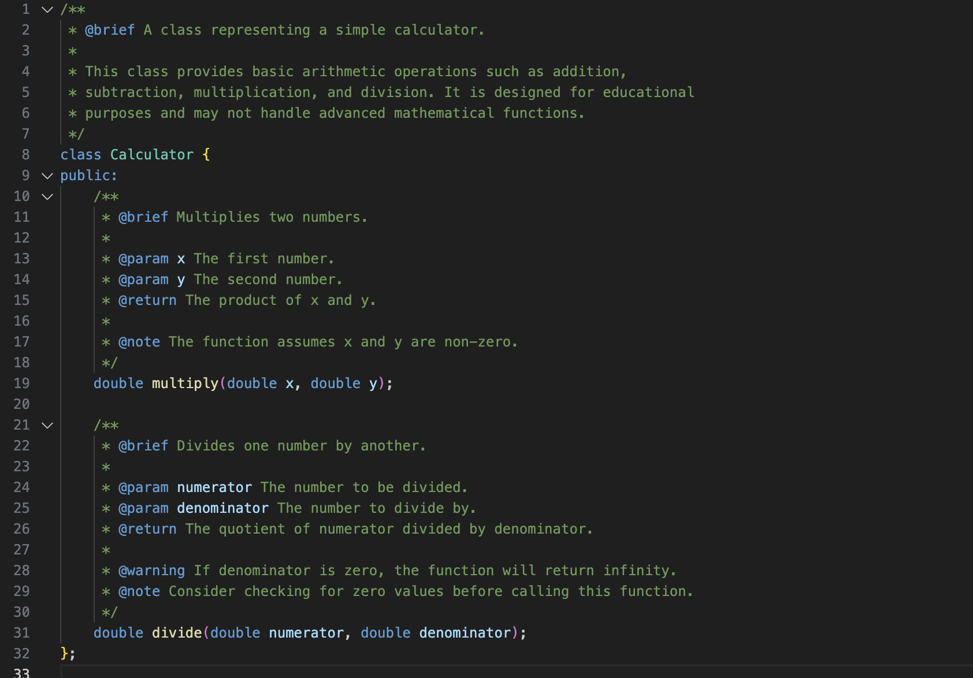
Explanation:
@brief: to provide an overview of the class’s purpose.
@param, @return, @note, @warning: to provide critical usage information

- Discussion Topics
a). For Complex Algorithms:
When documenting functions with complex logic, it is important to break down the algorithm step by step in the comments.
(use @note to explain the approach and assumptions made)
b). Edge Cases and Performance Considerations:
Discuss when and how to document edge cases using @warning and @note tags.
(Include examples of how to indicate potential performance impacts)
c). Consistency Across the Project:
Maintaining a consistent style in comments is crucial for readability. Developers are encouraged to share their methods for ensuring uniformity across large codebases.

- Best Practices

a). Keep Comments Concise:

Use @brief for short summaries and expand only when necessary.

b). Use Complete Sentences:

This improves readability and ensures clarity.

c). Avoid Over-Commenting:

Comments should provide value; avoid stating the obvious, such as commenting on simple variable assignments or loops unless they have specific importance.

- Feedback and Collaboration

a). Interactive Comment Review Sessions:

Developers can participate in bi-weekly sessions to review and discuss code comments. These sessions focus on improving clarity, consistency, and coverage of the comments.

b). Suggestions and Improvements:

Developers are encouraged to propose new commenting methods, or to refine existing ones, by opening discussion threads or submitting code patches.

c). Contribution Guidelines:

Ensure all new code contributions adhere to the established Doxygen guidelines. Use the provided templates for consistency.

